Mehdi M. Kashani

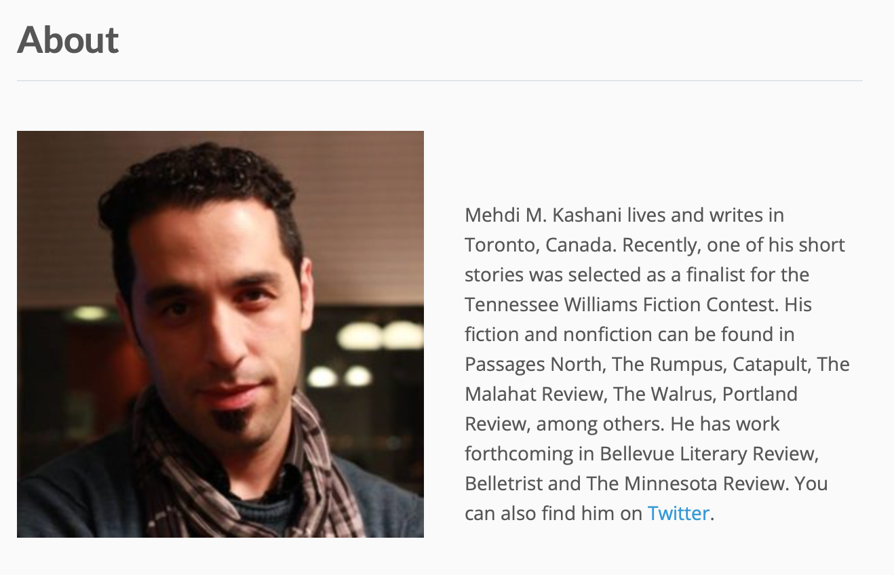

In addition to the above, Mehdi Kashani’s writing has been nominated for the Pushcart (twice) and for Best of Net, and he was a finalist for Canada’s National Magazine Awards. His website lists thirty-eight publications, including short fiction, flash fiction, drama, and non-fiction.

Carve Magazine

Mission statement from Carve’s website:
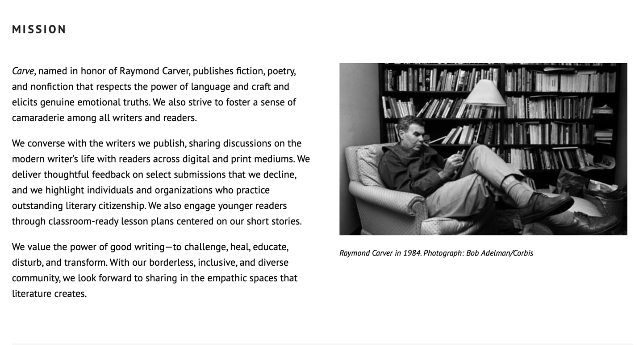

Other
According to Duotrope, Carve accepts 0.85% of submissions. Writers who submit fiction to Carve tend to also submit to: The Missouri Review, STORY Magazine, The Georgia Review, Joyland Magazine, Sun Magazine, West Branch, Sewanee Review, Bennington Review, Gettysburg review, Boulevard, CRAFT, and AGNI.

The New Quarterly

Excerpt from About section on The New Quarterly’s website:

About
The New Quarterly—TNQ, for short—is a Canadian literary journal known for wit, warmth, and literary innovation. Our style is celebratory, and we’re well known for finding, as well as nurturing, distinctive voices, and for continuing to support writers throughout their career. We publish short fiction, poetry, and creative nonfiction that explores both the craft and the writing life. Watch for TNQ writers among those cited for National Magazine Awards, the Man Booker Prize, the Scotiabank Giller Prize, the Griffin Poetry Prize, the Commonwealth Writers’ Prize, the Journey Prize, and the Writers Trust Fiction Prize.

Each issue brings our readers work by both emerging and established writers, and, while TNQ has always been an inclusive publication, we have renewed our commitment to encouraging writers who may be experiencing barriers regarding race, gender, ability, sexual orientation, or age to consider TNQ when they’re ready to submit their finest work.

Other
According to Duotrope, The New Quarterly accepts 8.00% of submissions. Writers who submit fiction to The New Quarterly also submit to: Malahat Review, PRISM International, Grain Magazine, ROOM Magazine, The /ternz/ Review, Minola Review, CBC Short Story Prize, Blue Earth Review, Greensboro Review.

